Created with Claude AI

Call center BI agent: analysis
An agentic AI concept for contact center analytics: architecture, initial and follow-up UI, and a possible underlying data model.

1. Concept
The call center BI agent takes a plain-language question about queues, agents, or call outcomes, queries the contact center data model, validates the result, and returns a narrative answer alongside the query that produced it — built for floor managers and workforce planners who need an answer faster than a dashboard build cycle allows.
What makes it agentic rather than just AI-powered: it plans multi-step work, uses tools (the semantic model, the query engine, validation checks) to gather and verify information, and adapts — retrying with a corrected query — based on intermediate results.

2. Architecture
1. User question — a natural language ask from a supervisor or workforce planner, e.g. “which queue had the longest hold time last week?”
2. Agent planner — reads the question, decides which fact and dimension tables it needs, and drafts a query plan. Business context (e.g. how “abandonment rate” is defined, service-level targets) is injected here.
3. Query engine — executes against the contact center data model: DAX against a Power BI dataset or SQL against the warehouse. Kept as a thin, tool-callable layer rather than letting the LLM write raw connection strings.
4. Validation — row-count sanity checks, null/outlier flags, and a check that the result actually answers the question asked. On failure it loops back to the planner with the error as context.
5. Output — a short narrative plus a chart, with the underlying query attached so a human can audit it.

3. Initial screen
- Header — app name and a status badge naming the connected model (“Connected: contact center model”)
- Prompt — “What do you want to know?” with guidance to ask about queues, agents, or call outcomes
- Question box — a multi-line text box with an example placeholder and a circular submit button
- Suggested prompts — three example questions as clickable chips (avg handle time by team, lowest CSAT, abandonment rate by hour)
- Live stat cards — three at-a-glance stat cards — calls today, average wait, CSAT — so the floor's pulse is visible before any question is asked
- Trust line — a muted line: “Every answer is validated against the model before it's shown to you”
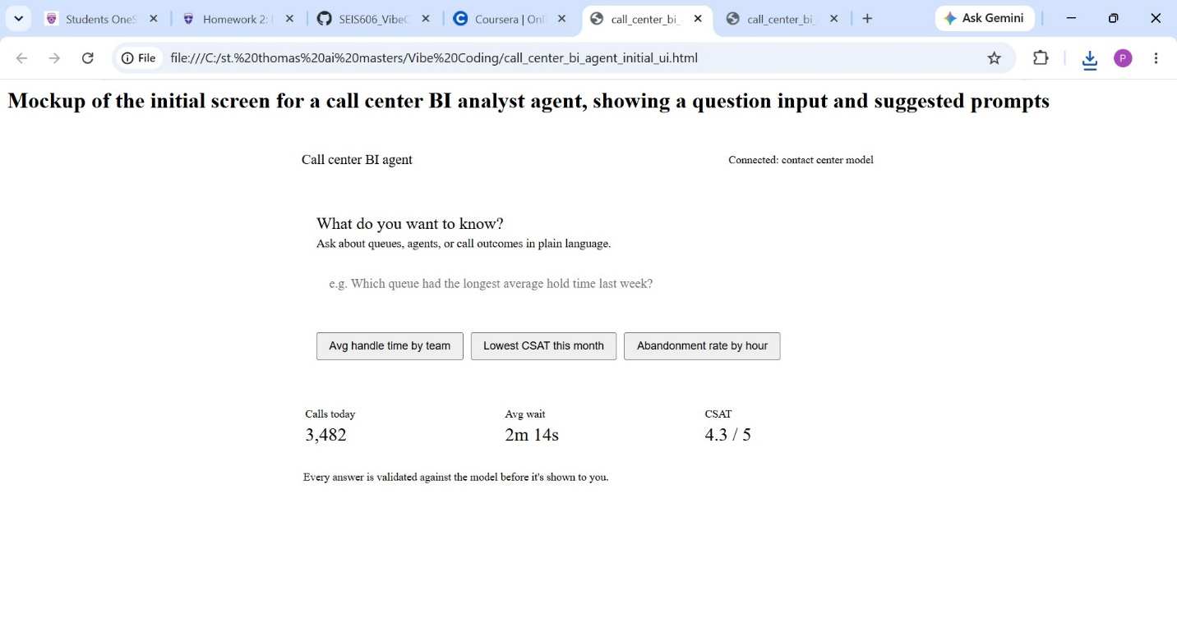

4. Follow-up (results) screen
- Question echo — the user's question echoed back as a right-aligned message bubble
- Validation badge — a green check plus “Validated against contact center model” shown before any numbers
- Narrative summary — 2–3 sentences answering the question directly, including a plausible root cause (e.g. a staffing gap) rather than just the number
- Chart — a horizontal bar chart of queues by hold time, with the outlier queue flagged in a warning color
- Query disclosure — a collapsed “View query” section revealing the actual DAX/SQL in monospace
- Follow-up box — a persistent input at the bottom for follow-up questions
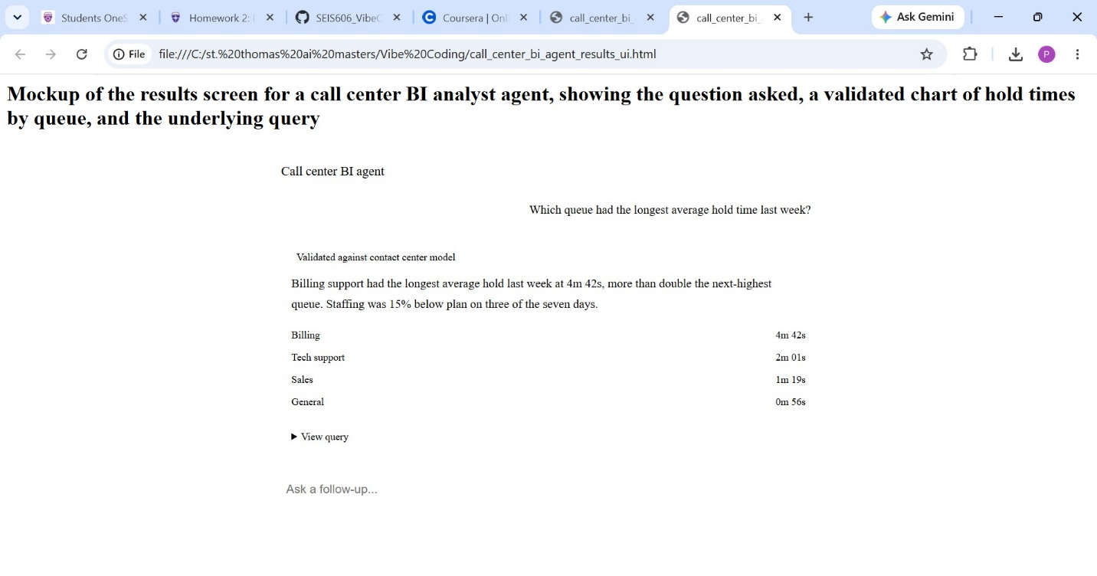

Screen elements at a glance
Element | Initial screen | Results screen
Primary focus | Question input | Answer + chart
Trust signal | Connected data source badge | Validated status badge
Guidance | Example prompt chips | Follow-up input
At-a-glance data | Live stat cards | Collapsible query view

5. Possible database model
A star schema fits this use case well: a single Calls fact table at the grain of one call, surrounded by dimension tables the agent's query engine can join against. This keeps the agent's generated queries simple and predictable — mostly filters and joins on well-known keys — which is also what makes the validation step tractable.
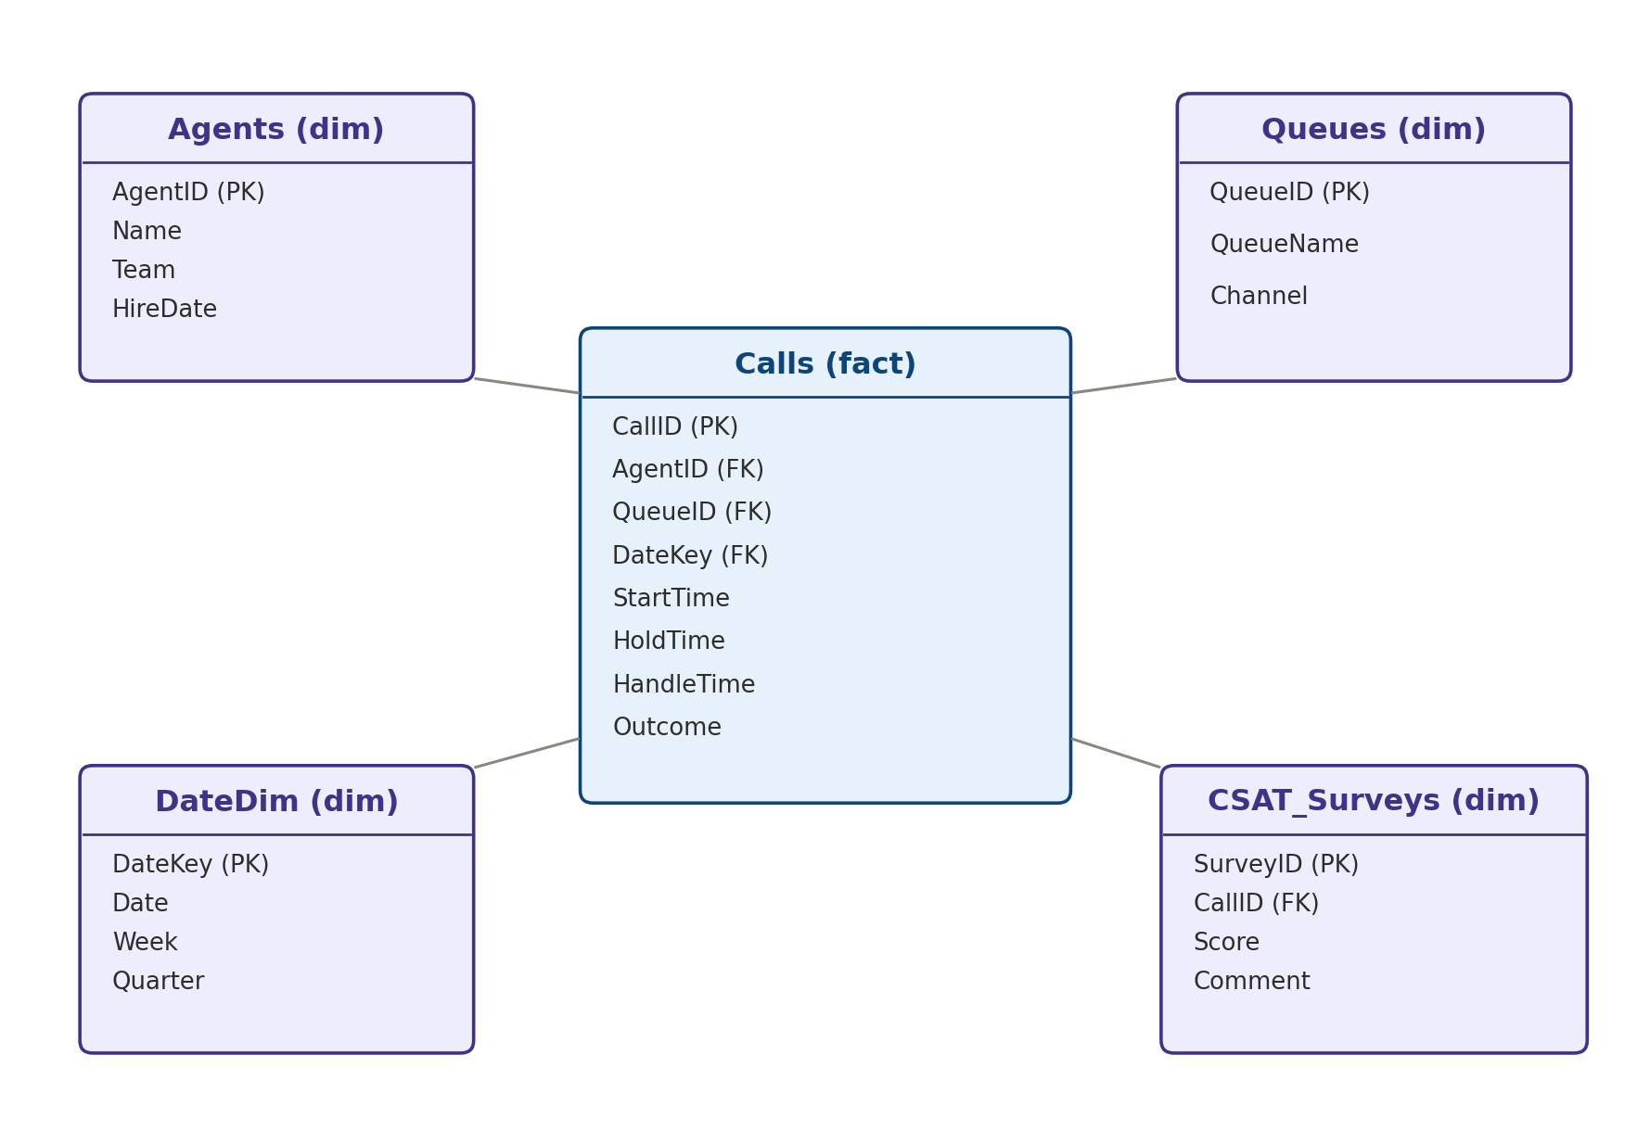
- Calls (fact) — one row per call; holds the measures the agent aggregates (hold time, handle time) and the foreign keys to every dimension
- Agents (dim) — agent roster — supports questions like “which agents…” or “by team”
- Queues (dim) — queue/channel metadata — supports “which queue…” questions
- DateDim (dim) — standard date/week/quarter hierarchy — supports “last week”, “this quarter” style questions
- CSAT_Surveys (dim) — post-call survey results, joined back to the call — supports CSAT and comment-driven questions
This is a starting point rather than a finished schema — a real implementation would likely add an Interactions or Transfers table for multi-touch calls, and a Schedules table if the agent needs to reason about staffing versus plan.

